Blocking Rule Clarification

A block is the action of a player close to the net that deflects the ball coming from the opponent by reaching higher than the top of the net. In the illustration below, the picture on the right is not a block. Player # 7 does not reach higher than the top of the net. In the picture on the right, Player # 7 is reaching higher than the top of the net. If Player # 7 deflects the ball it will be considered a completed block. If Player # 7 does not deflect the ball it would be considered a block attempt.
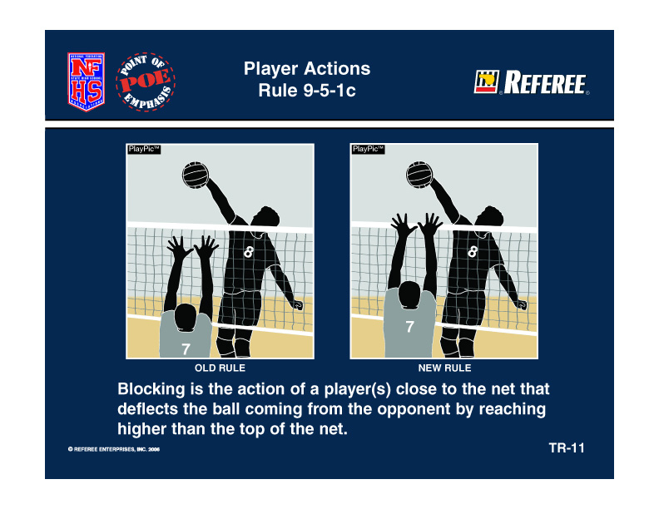

The term collective block was also added to the rules. Using the revised definition of a block (must reach higher than the top of the net, and must deflect the ball), a collective block involves more than one blocker. An attempt with no contact is not a block. (At no time may a libero block or attempt to block.)

The picture below depicts a collective block with Player # 3 reaching higher than the net and deflecting the ball coming from the opponent. Both players are considered to be part of the block because both players are in close proximity and both players are reaching higher than the top of the net. Player # 6 is a back-row player making this completed collective block illegal and the appropriate call by the officials is back-row block.

BACK-ROW PLAYER – COLLECTIVE BLOCK
SITUATION: A back-row player from Team A approaches the net along with a front row player and attempts to block a ball coming from the opponent. Both the back-row and front row players are close to the net and shoulder to shoulder in what appears to be a possible collective block. As the ball crosses the net (a) some part of the hands of both players are above the height of the net as the ball is contacted by the front row player; (b) some part of the hands of both players start out above the height of the net but when the front row player contacts the ball the back-row player is no longer above the height of the net; (c) both players attempt to block the ball but the back-row player never gets higher than the top of the net, but the front row player does block the ball. The official blows the whistle and signals an illegal block in (a). In (b) and (c) the official lets play continue. RULING: In (a) correct procedure. Both players met the conditions of being close to the net, reaching higher than the net and deflecting the ball. Both players were above the height of the net at the moment of contact with the ball. In (b) and (c) correct procedure. Although the back-row player was close to the net, she was not above the height of the net at the moment of contact when the ball was deflected by the front row player who was above the height of the net. Therefore the back-row player was not participating in a collective block. Play continues in (b) and (c) and Team A has three allowable hits unless the block prevented the ball from crossing the net. (9-5-1c, 9-5-1c 1-3)

